Priority – 1:

Job Recission Prediction System: https://ieeexplore.ieee.org/document/10368645

Reference: <https://www.aptech.com/blog/predicting-recessions-with-machine-learning-techniques/>

Priority – 2:

Fake Job Post Prediction: Countvec, GloVe, Bert:

Reference: <https://www.kaggle.com/code/vikassingh1996/fake-job-post-prediction-countvec-glove-bert#Sequential-Neural-Net>

Priority – 3:

Data Science Job & Salary Prediction (Glassdoor):

Reference: <https://www.kaggle.com/code/fahadrehman07/data-science-job-salary-prediction-glassdoor/notebook#ModelBuilding>

# PICO-1:

Problem: Forecasting Job Rescission in the Industry.

Intervention: Using the KNN algorithm predicting the accuracy.

Comparison: Using the Decision Tree as the Baseline model with KNN model.

Outcome: Compared based on the accuracies.

Problem: Forecasting Job Rescission in the Industry.

Intervention: Using the SVM algorithm predicting the accuracy.

Comparison: Using the Decision Tree as the Baseline model with KNN model.

Outcome: Compared based on the accuracies.

Problem: Forecasting Job Rescission in the Industry.

Intervention: Using the Random Forest algorithm predicting the accuracy.

Comparison: Using the Decision Tree as the Baseline model with KNN model.

Outcome: Compared based on the accuracies.

Problem: Forecasting Job Rescission in the Industry.

Intervention: Using the XGBoost algorithm predicting the accuracy.

Comparison: Using the Decision Tree as the Baseline model with KNN model.

Outcome: Compared based on the accuracies.

PICO

Title-1: "Evaluating the precision of Random Forest vs Support Vector Machines for Forecasting Job Rescission in the Industry."

P (Problem): The unpredictability of job rescission in the industry poses a challenge for workforce stability and strategic planning.

I (Intervention): Applying Random Forest (RF) and Support Vector Machines (SVM) as machine learning models to predict job rescission based on historical industry data.

C (Comparison): Comparing the performance of Random Forest vs. Support Vector Machines in terms of precision, recall, F1-score, and overall accuracy to determine which model is more suitable for job rescission forecasting.

O (Outcome): Leading to better forecasting accuracy, reduced false positives/negatives, and improved decision-making for businesses and policymakers.

Title-2: ‘’A Comparative Analysis of Decision Tree and Support Vector Machines for Predicting Job Rescission in the Industry"  
  
Problem (P): Job rescission prediction is crucial for workforce planning and economic stability.

Intervention (I): Applying Decision Tree and SVM models to predict job rescission based on industry-specific factors such as economic indicators, company financials, and employment rates.

Comparison (C): Comparing the precision, recall, F1-score, and overall accuracy of Decision Tree vs. Support Vector Machines in forecasting job rescission trends.

Outcome (O): Identifying which model provides better predictive accuracy and lower error rates in job rescission forecasting, enabling more reliable workforce management strategies.

Title-3:"Enhancing Job Rescission Forecasting: XGBoost vs. Support Vector Machines Performance Evaluation"

Problem (P): Predicting job rescission accurately remains a challenge, requiring robust machine learning techniques.

Intervention (I): Utilizing XGBoost and SVM to analyse industry data, including workforce trends, financial downturns, and economic indicators, for predicting job rescission.

Comparison (C): Evaluating XGBoost vs. SVM in terms of precision, recall, F1-score, and computational efficiency.

Outcome (O): Determining whether XGBoost outperforms SVM in predictive accuracy, allowing for better decision-making in workforce planning and risk mitigation.

Title-4:"Assessing the Predictive Accuracy of K-Nearest Neighbors vs. Support Vector Machines for Job Rescission Forecasting"

Problem (P): Job rescission forecasting requires machine learning models that can handle industry-specific complexities. While SVM is a powerful classifier, K-Nearest Neighbors (KNN) may provide competitive accuracy.

Intervention (I): Implementing KNN and SVM on job market data, considering factors such as employment trends, industry growth, and financial stability, to predict job rescission.

Comparison (C): Comparing the predictive accuracy, precision, recall, and computational efficiency of KNN vs. SVM for forecasting job rescission.

Outcome (O): Identifying whether KNN provides better or comparable predictive performance than SVM, helping industries make informed workforce decisions.

# Sample Size:

Comparison: SVM – 89.2 – Calculated: 94.38

Title-1: Random Forest – 96.2 – Calculated: 96.97

Title-2: Decision Tree – 95.3 – Calculated: 98.20

Title-3: XGBoost – 98.8 – Calculated: 98.88

Title-4: KNN – 96.1 – Calculated: 95.51

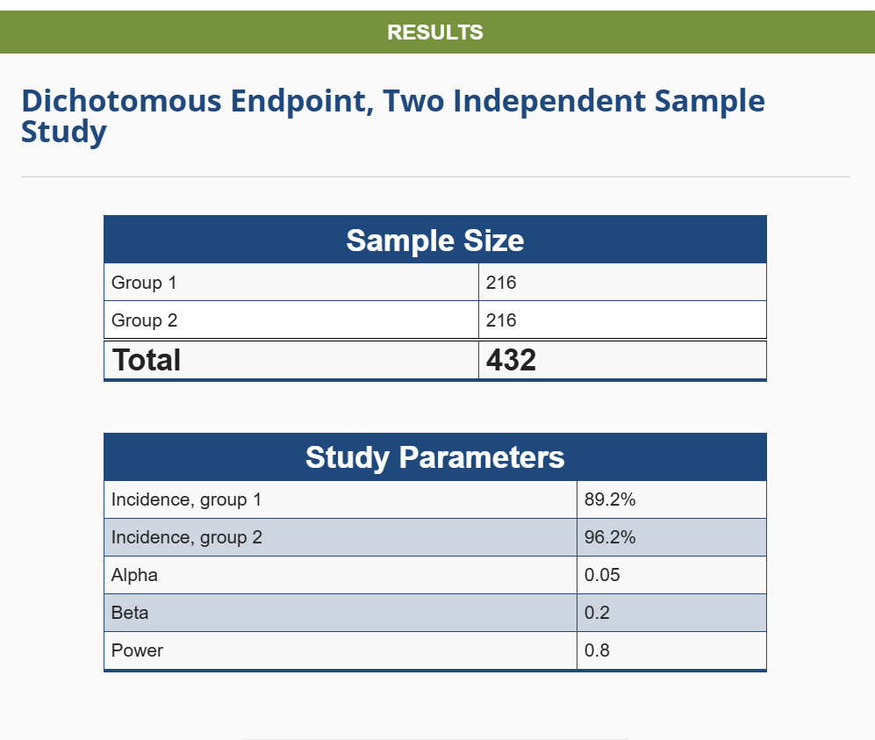 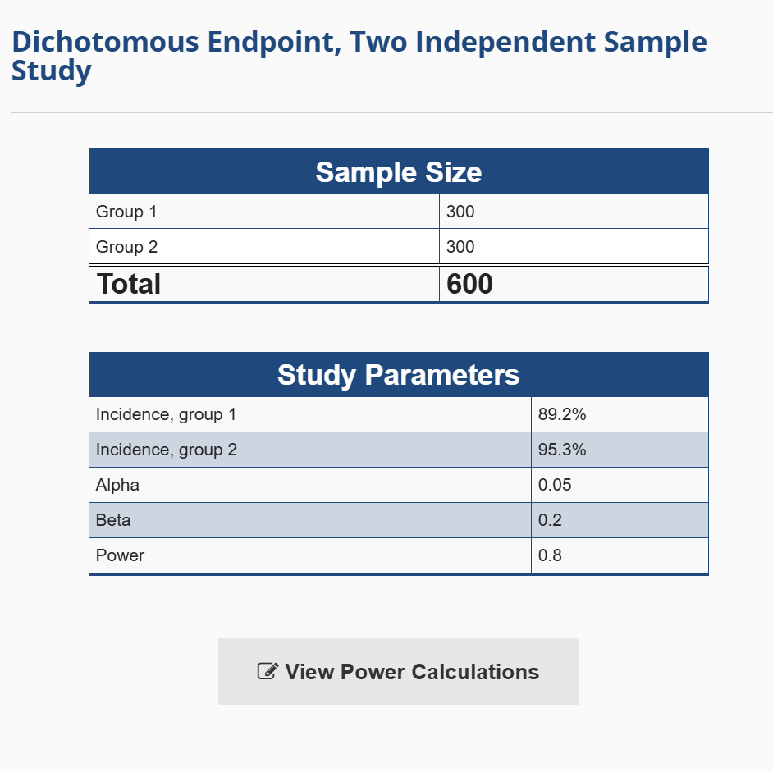

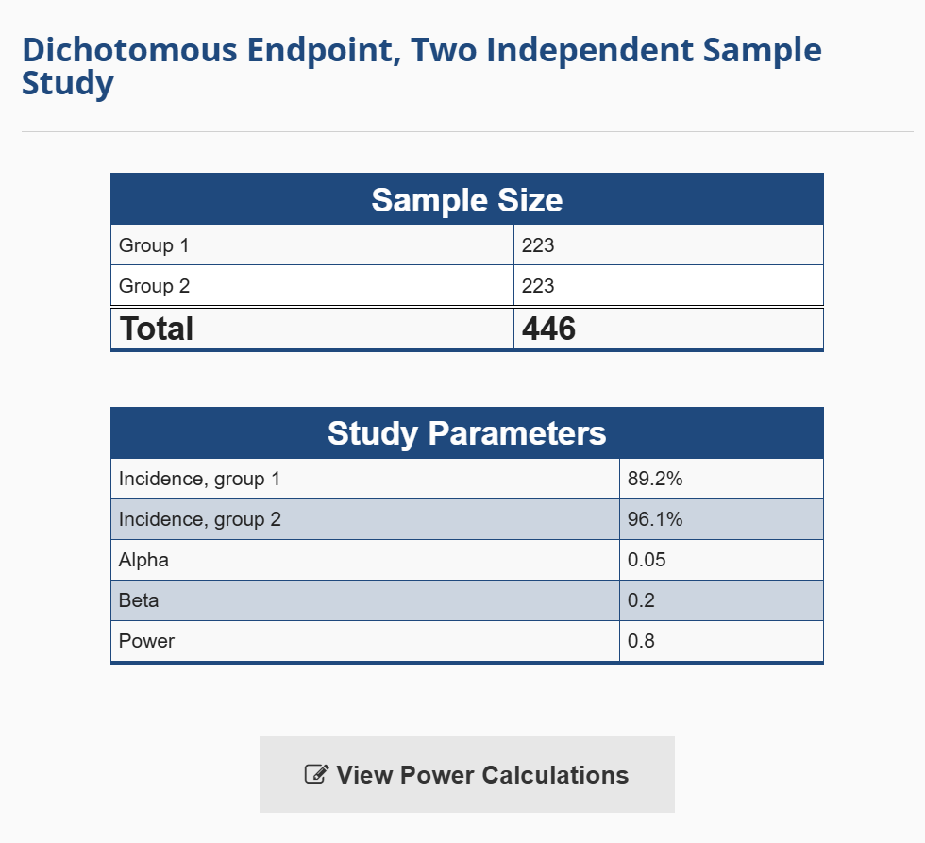 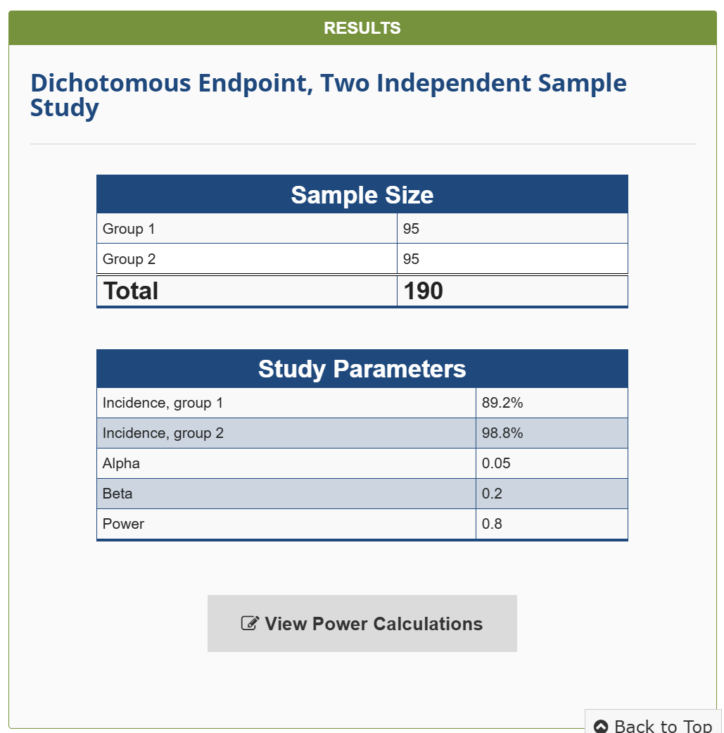

1. **GS10 (10-Year Treasury Yield)**
   * The **yield on the U.S. 10-year Treasury bond**.
   * A key indicator of **long-term interest rates** and economic expectations.
   * Often used as a benchmark for mortgages and corporate bonds.
2. **GS3M (3-Month Treasury Yield)**
   * The **yield on the U.S. 3-month Treasury bill**.
   * Represents **short-term interest rates**, closely tied to Federal Reserve policy.
   * Used in calculating the **yield curve spread** (e.g., GS10 - GS3M).
3. **FCI (Financial Conditions Index)**
   * Measures the **tightness or looseness** of financial conditions.
   * Includes **interest rates, credit spreads, stock market performance, and liquidity measures**.
   * Could refer to indices like **Goldman Sachs FCI** or **Chicago Fed NFCI**.
4. **SPREAD10_3FOR (10-Year vs. 3-Month Yield Spread - Forward Looking)**
   * Likely represents the **spread between the 10-year and 3-month Treasury yields**.
   * A key indicator for predicting **economic recessions**.
   * When **GS10 < GS3M**, it indicates an **inverted yield curve**, which often signals a recession.

Economic indicators like **GS10, GS3M, FCI, and yield spreads** play a critical role in predicting **unemployment** and **recessions**. Here's how:

**1️⃣ Yield Curve (GS10 - GS3M or SPREAD10_3FOR) & Recession Prediction**

The difference between **long-term and short-term interest rates** (e.g., **10-year Treasury yield (GS10) - 3-month Treasury yield (GS3M)**) is called the **yield spread**.

🔹 **Normal Yield Curve (Positive Spread, GS10 > GS3M)**

* Long-term rates are higher than short-term rates.
* **Signals economic expansion** (borrowing is cheap, investment increases).

🔹 **Inverted Yield Curve (Negative Spread, GS10 < GS3M)**

* Short-term rates are **higher than long-term rates**.
* Investors expect lower future growth and **possible recession**.
* Historically, **an inverted yield curve has preceded nearly every U.S. recession** in the past 50 years.

📌 **Example:**

* **1980, 1990, 2001, 2008, 2020**: Before each of these recessions, the **yield curve inverted**.

✅ **How It Relates to Unemployment?**

* **Inverted Yield Curve → Recession → Businesses Cut Costs → Layoffs → Unemployment Rises**

**2️⃣ Financial Conditions Index (FCI) & Recession Prediction**

🔹 **FCI (Financial Conditions Index)** measures how easy or tight financial conditions are by considering:

* **Interest rates** (higher rates → borrowing costs rise).
* **Credit spreads** (wider spreads → financial stress).
* **Stock market performance** (falling markets signal risk aversion).
* **Liquidity levels** (low liquidity → economic slowdown).

📌 **How FCI Helps Predict Unemployment?**

* **Tight Financial Conditions (High FCI Value)** → Harder to borrow → Less investment → **Hiring slows → Unemployment rises**.
* **Loose Financial Conditions (Low FCI Value)** → Easier to borrow → More investment → **Lower unemployment**.

✅ **Historical Example:**

* **2008 Financial Crisis**:
  + FCI tightened rapidly before the recession.
  + Unemployment **jumped from 4.5% to 10%** in two years.

**3️⃣ Credit Spread (SPREAD10_3FOR) & Economic Stress**

🔹 **Corporate Bond Spread (SPREAD10_3FOR, AAA - BAA spread)**

* Measures the **risk premium** on corporate bonds.
* A **wider spread** means investors demand higher returns due to increased risk.

📌 **How It Predicts Recession & Unemployment?**

* **Wide Credit Spread** → Investors fear corporate defaults → Banks tighten lending → **Less investment & more layoffs**.
* **Narrow Credit Spread** → Confidence in the economy → More borrowing → **Lower unemployment**.

✅ **Example:**

* **Before the 2008 Crisis**, the spread between AAA & BAA bonds widened significantly, signaling higher credit risk and impending recession.

**🔍 Summary: How These Indicators Predict Recession & Unemployment**

| **Indicator** | **What It Shows** | **Impact on Recession** | **Impact on Unemployment** |
| --- | --- | --- | --- |
| **Yield Spread (GS10 - GS3M)** | Interest rate expectations | **Negative spread → Recession** | **Higher unemployment** follows recession |
| **FCI (Financial Conditions Index)** | Financial stress in markets | **High FCI → Credit tightens → Slowdown** | **Less hiring → Job losses** |
| **Credit Spread (SPREAD10_3FOR)** | Risk perception in corporate bonds | **Wider spread → Recession risk rises** | **Companies cut jobs to reduce costs** |

**🔹 Final Takeaway**

📌 **Most recessions and spikes in unemployment have been preceded by:**  
✅ **An inverted yield curve (GS10 < GS3M)**  
✅ **Tighter financial conditions (High FCI)**  
✅ **Widening corporate bond spreads (SPREAD10_3FOR)**

|  |  |  |  |  |
| --- | --- | --- | --- | --- |
| Decision Tree | Random Forest | SVM | XGBoost | KNN |
| Epoch 1: Accuracy = 0.9775  Epoch 2: Accuracy = 0.9775  Epoch 3: Accuracy = 0.9775  Epoch 4: Accuracy = 0.9775  Epoch 5: Accuracy = 0.9888  Epoch 6: Accuracy = 0.9888  Epoch 7: Accuracy = 0.9775  Epoch 8: Accuracy = 0.9888  Epoch 9: Accuracy = 0.9888  Epoch 10: Accuracy = 0.9775 | Epoch 1: Accuracy = 0.9775  Epoch 2: Accuracy = 0.9775  Epoch 3: Accuracy = 0.9888  Epoch 4: Accuracy = 0.9663  Epoch 5: Accuracy = 0.9663  Epoch 6: Accuracy = 0.9663  Epoch 7: Accuracy = 0.9551  Epoch 8: Accuracy = 0.9663  Epoch 9: Accuracy = 0.9663  Epoch 10: Accuracy = 0.9775 | Epoch 1: Accuracy = 0.9438  Epoch 2: Accuracy = 0.9326  Epoch 3: Accuracy = 0.9551  Epoch 4: Accuracy = 0.9551  Epoch 5: Accuracy = 0.9438  Epoch 6: Accuracy = 0.9438  Epoch 7: Accuracy = 0.9551  Epoch 8: Accuracy = 0.9438  Epoch 9: Accuracy = 0.9551  Epoch 10: Accuracy = 0.9438 | Epoch 1: Accuracy = 0.9326  Epoch 2: Accuracy = 0.9888  Epoch 3: Accuracy = 0.9663  Epoch 4: Accuracy = 0.9438  Epoch 5: Accuracy = 0.9888  Epoch 6: Accuracy = 0.9663  Epoch 7: Accuracy = 0.9888  Epoch 8: Accuracy = 0.9775  Epoch 9: Accuracy = 0.9438  Epoch 10: Accuracy = 0.9326 | Epoch 1: Accuracy = 0.9326, k = 3 Epoch 2: Accuracy = 0.9438, k = 4 Epoch 3: Accuracy = 0.9551, k = 5 Epoch 4: Accuracy = 0.9438, k = 6 Epoch 5: Accuracy = 0.9326, k = 7 Epoch 6: Accuracy = 0.9551, k = 3 Epoch 7: Accuracy = 0.9438, k = 4 Epoch 8: Accuracy = 0.9326, k = 5 Epoch 9: Accuracy = 0.9551, k = 6 Epoch 10: Accuracy = 0.9551, k = 7 |
| 0.9820 | 0.9708 | 0.9472 | 0.9629 | 0.9449 |